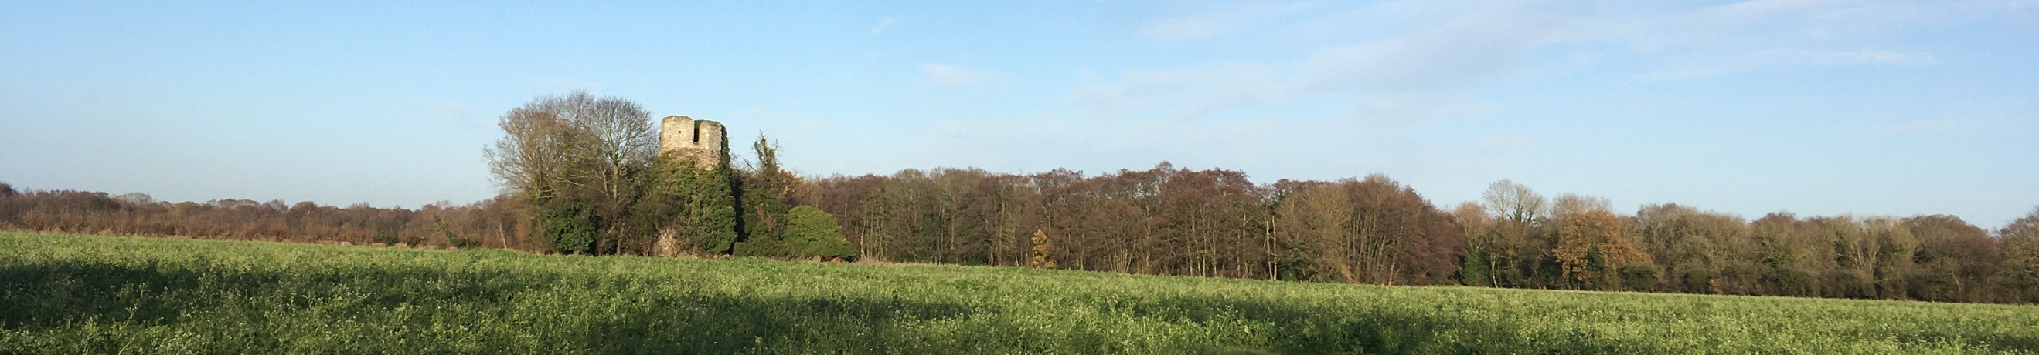

Fleggburgh Neighbourhood Development Plan
Regulation 14 Consultation on the Draft Plan
27th August to 30th October

Introduction
Thank you for supporting development of a Neighbourhood Plan for Fleggburgh, which will help to influence future development of our parish and three villages.
This survey will seek your views on the pre-submission draft of our Neighbourhood Plan, the Regulation 14 Version. The questions below ask for your feedback on each individual policy within the plan. The full document is available to view on the Parish Council website https://fleggburghpc.norfolkparishes.gov.uk, in hard copy from the Village Hall or by contacting Dr Jimmy Miller, Parish Clerk on 07502735991 or by emailing the Neighbourhood Development Plan email address ndpfleggparish@outlook.com, and contains more detail and context to the policies.

How the information from this consultation with be used
Information given on this form will be used to help prepare the final Fleggburgh Neighbourhood Plan for examination. Please be aware that the forms will be shared with the Parish Council’s Planning Consultants and your comments may be made publicly available, for example, if a challenge is made regarding the validity of responses.

Please use this form for your comments and submit your response in one of the following ways:
- Email as an attachment to: ndpfleggparish@outlook.com,
- Post copies to the Parish Clerk at 71 The Common, Freethorpe, Norfolk, NR13 3LX
- Complete the survey online at: https://www.smartsurvey.co.uk/s/Fleggburgh/

Please complete your response online if possible, the online survey includes all the policy text and related maps. Further copies of this form can be downloaded from the Fleggburgh Parish Council website.

What happens next:
After the closing date, we will consider the comments and the extent to which concerns can be addressed. The draft plan, amended as necessary will then be submitted to Great Yarmouth Borough Council who will publicise the draft plan. This provides further opportunity for people to make representations about the plan’s proposals. The next stages following this will be:
- Submission of the draft plan for independent examination;
- Publication of the independent examiner’s report and decisions;
- A referendum of residents on the draft plan; and
- If the referendum result supports the draft plan it will ‘made’ and become part of the development plan.

The closing date for comments is 30th October 2020
General Comments:

I am generally in favour of the Plan  YES/NO | I would like to see changes to the Plan  YES/NO
Comments on the Plan overall:

Comments on each of the policies:
Policy No. | Policy Name | Do you agree?  Delete as appropriate | Any comments you have on the policy
Housing
Policy 1 | Housing Type & Mix | YES/NO
Policy 2 | Design | YES/NO

Natural Environment
Policy 3 | Enhancing the Natural Environment | YES/NO
Policy 4 | Local Green Space | YES/NO
Policy 5 | Landscape Setting | YES/NO
Policy 6 | Dark Skies | YES/NO
Policy 7 | Surface Water Management | YES/NO

Built Environment
Policy 8 | Village Centre | YES/NO
Policy 9 | Heritage Assets | YES/NO

Community Infrastructure
Policy 10 | Sustainable Transport | YES/NO
Policy 11 | Traffic & Speed | YES/NO
Policy 12 | Communications | YES/NO
Policy 13 | Village Shop | YES/NO

